Practice exercise: Import external data
Name: ______Andrew-Nicholas Rusu________________________________________________

Deliverable:
- Upload EmployeesOrders.accdb in LEA in the Assignments section.

Part 1.
- Create a blank database with the name EmployeesOrders.accdb
- Import Excel files (EmployeesOrders.xlsx), in the blank database.
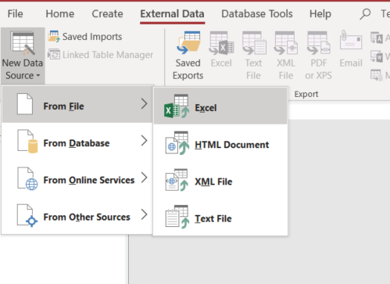

- Check the following option

What do you think step #3 is for? To put column headings for the first row.

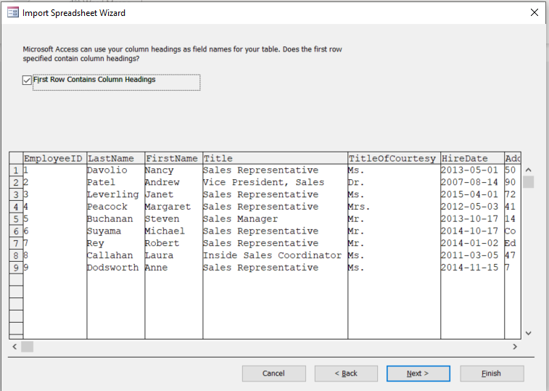

- Make sure your column EmployeeID is indexed and does not allow duplicates.
What do you think step #4 is for? To index the field and prevent duplicates in the database.

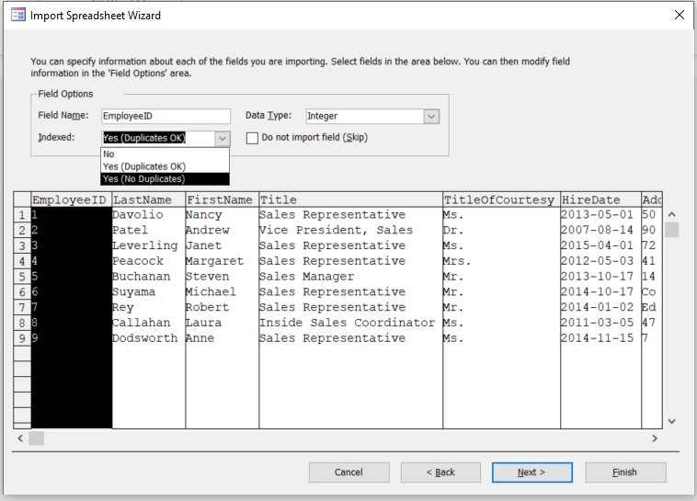

- Make sure you select column EmployeeID as primary key.
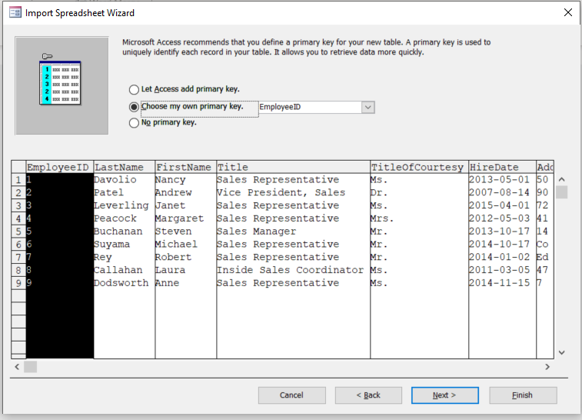

- List the columns with the data types assigned by the wizard.

